|  |  |  |
| --- | --- | --- |
| **Rothamsted weather data – exercise for secondary schools** |  |  |

# Daily weather data: Use the dataset SCHOOLMETDAY

**Important:** You will require a password to extract data from the e-RA database – contact the e-RA curators in advance by email to obtain a password (res.era@rothamsted.ac.uk)

In this exercise, we are looking at how to extract data from our database for one day or a whole year, and then some of the ways we can analyse this data. Rothamsted has developed e-RA, the electronic Rothamsted Archive, to keep the results of **the long term experiments** and other information like **weather data**.

# *The weather for one day*: Select a date from SCHOOLMETDAY (perhaps your birthday!):

# Select SCHOOLMETDAY, check (tick) all left hand boxes, and check ‘day’ on right hand box (as shown below). Then go to ‘Filter’ and type in your date. Select ‘accept’ then go to ‘Retrieve’ and select ‘extract data’.

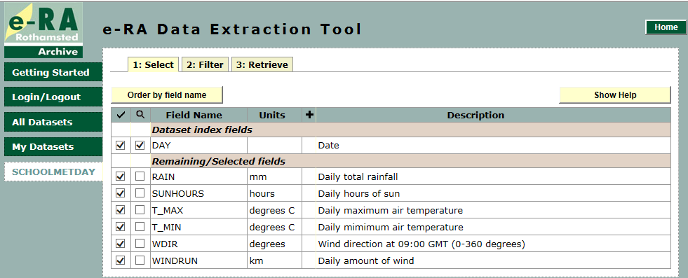

Date: ____________________________

There were ______________mm of rain. The sun shone for ________ hours.

The wind direction was _________ degrees. The total amount of wind was ________ km.

At its coldest it was ______________ °C and at its hottest it was __________________ °C

The mean was: ____________________ °C. *You will need to calculate this yourself*:

The mean temperature is (T_MAX + T_MIN) / 2

For example, on 01/06/1999, **T_MAX** = 21.0 °C, **T_MIN** = 10.2 °C. (21.0 + 10.2) / 2 = 15.6 **°C**

1. ***The weather for a whole year:***

**Graph showing the daily T_max, T_min and mean temperature for 2011**

**(data extracted from the dataset for schools called ‘SCHOOLMETDAY’)**

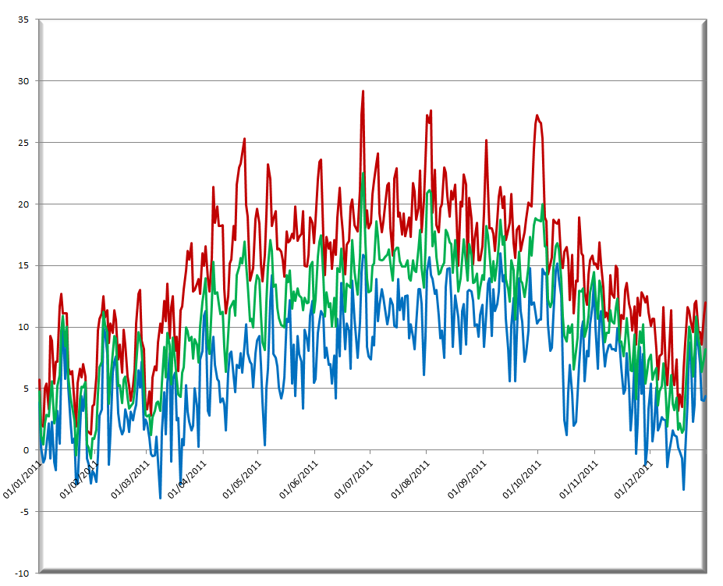

Date

Temperature degrees C

|  |  |
| --- | --- |
|  |  |

The blue line represents the **coldest** temperature every day,

the red line the **hottest**

and the green line the **mean**.

The average temperature for that year would be the average of all the means. (That is a good enough approximation). Average: 10.84 ⁰C

1. ***Your turn….!***

Now you extract data for one year from e-RA dataset ‘SCHOOLMETDAY’ and analyse it with excel

|  |  |  |  |
| --- | --- | --- | --- |
| **Year** | 2011 |  |  |
| **Hottest day** | 27 June: 29.2⁰C |  |  |
| **Coldest day** | 8 March: -3.9⁰C |  |  |
| **Average temp** | 10.84 ⁰C |  |  |
| **Wettest day** |  |  |  |
| **Driest day** |  |  |  |
| **Sunniest day** |  |  |  |
| **Windiest day** |  |  |  |

1. In my days, those of my parents, grandparents …